Why ad hoc deletes and refreshes exist
- Merge duplicates in the hub: Merges happen at the spoke level. If two records merge after both already reached the hub, one must be deleted manually in the data lake and Informatica. A past code flaw skipped this, leaving duplicates in the hub that flow to Salesforce and generate tickets.
- Unmerge requests: The business wants a merged record split apart again.
- Consolidated → unconsolidated moves: The business wants a record moved out of consolidated.
How the DQM team triggers fixes
- Refresh only: They insert EIDs into the ADB refresh table. The next morning’s customer profile batch includes those EIDs even with no source changes, so they flow spoke → hub → Salesforce.
- Delete only: They insert EIDs into the ad hoc delete table (exact table name unknown). This is used for duplicates or consolidated → unconsolidated moves.
- Delete and refresh: They insert the EIDs into both tables.
Daily flow (weekdays)
- ~5:00 PM, data lake job: Deletes the EIDs from all Delta tables (consolidated, single view, transient). It does the hub first, then each spoke: insurance, investment, bank, retirement.
- Data lake writes delete files for Informatica, since Informatica can’t access Delta tables. That’s one file each for the hub and the spokes, always generated even if empty.
- ~5:30 PM, Informatica job: Picks up those files and deletes the same EIDs on the Informatica side.
- Informatica writes a refresh file listing the deleted EIDs, and a separate job loads it back into ADB refresh.
- Next morning: Records marked for refresh come back through the customer profile, get re-ingested in Informatica, sent to the hub, then to Salesforce.
Relevance to your change
The delete file has two columns: enterprise ID and source system code. If deletes are done at the source system code level, you’ll need to add the GB source system code to the hub code. If they’re done at the EID level only, no hub changes are needed.

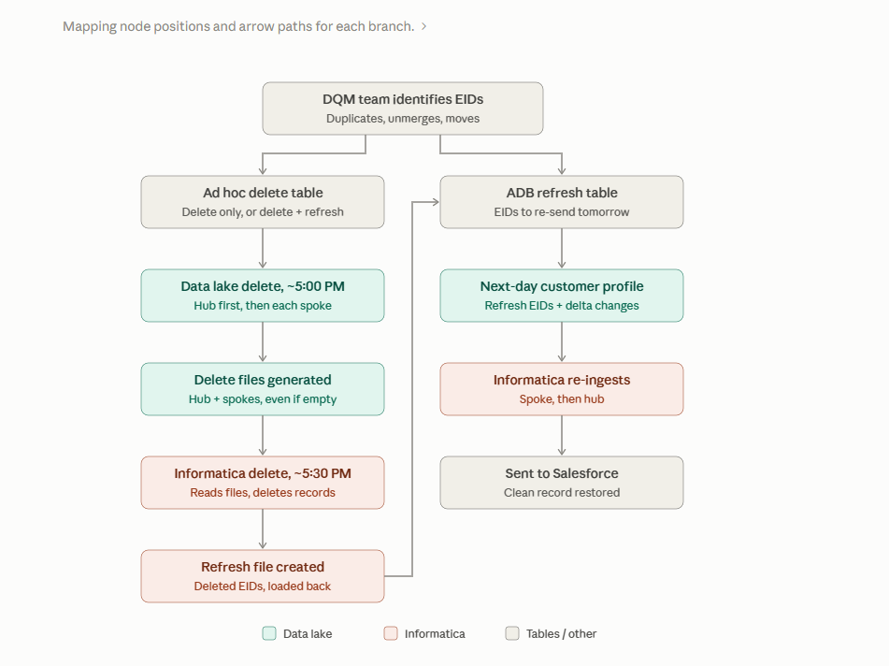

:
Copilot summary .:
What it confirms or fills in
- Delete table name: adhoc_delete_spoke_hub. One table feeds both the hub and spoke notebooks.
- Empty-file rule: Hub_Delete_EIDs.py writes an empty Informatica CSV and exits when there are no EIDs today, matching what Shiva described.
- Spokes have their own notebooks: delete_eids_cust_bank_dqm.py handles bank (four tables, plus its own CSV for Informatica). Insurance, investment, and retirement likely have equivalents, possibly in other repos.
What’s new or different from the call
- Hub deletes hit five tables, not three: single view, consolidated, transient, unconsolidated, and organization.
- The hub notebook itself prepares refresh records for what Copilot calls the “Hash ADV refresh table” (probably ADB refresh, misread). Shiva described Informatica’s refresh file feeding that table. Both paths may exist, so it’s worth checking.
- “Captures deletion details” is probably the pre-image step.
- ACS indexer: the hub notebook builds a deletion JSON and runs or checks an indexer, likely a search index. This wasn’t mentioned on the call.
- delete_eids_cust_hub_dqm.py works in the other direction. It reads hub_egress_source_deleted.csv and deletes from hub single view only. This may be a separate source-driven delete, not part of the DQM ad hoc flow.
What to check next in the code
- For your source system code question: in Hub_Delete_EIDs.py lines 263–290, see which columns it reads from adhoc_delete_spoke_hub. In lines 294–572, see whether the delete filter uses only EID/MDM customer ID or also source system code.
- Lines 845–908: the Hub-delete CSV layout, to confirm the two-column format.
- Schedule: Copilot found no job definition, so the 5 PM timing and run order live in the Databricks Jobs UI. Search there for the MDM hub ad hoc delete job you saw.

